

Space, Range and Merchandising Programme
Ranging Controls

Store Clustering
Business System Design

Author: S. Buchanan

Version: 1.0 – For Review

Document Sign-off

For sign-off:
Danielle Coe | SR&M Project Manager
Nick Robbins | SR&M IT Project Manager
Mark Rappit | SRM Planning and Change Manager
Mark Croft | Operations Manager
John Wootton | Range Programme Project Manager

For information:
Meryl Hanlon | SR&M IT Project Manager
Anne Broderick | SR&M IT

Document Control

Date | Author | Change Description | Version
17 Mar 2006 | Sue Buchanan | Created document for review | 1.0
4th Aug 2006 | Ingrid Stevens | Document updated following Business review | 1.1

Contents
1 Introduction 4
1.1 Document Purpose 4
1.1.1 Related Documents 4
1.2 Store Clustering - Business Benefits 4
1.3 Store Clustering - Risks and Issues 5
1.3.1 Risks 5
1.3.2 Issues 5
2 To-Be Business Process 6
2.1 To-Be Process Introduction 6
2.2 To-Be Process Overview 6
2.2.1 Store clustering activities 6
2.2.2 Ranging-only activities 7
2.3 To-Be Process Detail – System Functions 8
2.3.1 Scheduled Ranging Merchandising Event 8
2.3.2 UKBE Build a New Store 9
2.3.3 UKBE Store Extension 9
2.3.4 UKBE Re-fit 9
2.3.5 Create a new Attribute Value 9
2.3.6 Delete an Attribute Value 10
2.3.7 Create a new Attribute Type 10
2.3.8 Stop using an Attribute Type for Ranging Purposes 10
3 System Design 11
3.1 Store Clustering Functionality - Screen Designs 11
3.1.1 Screen SC01: Maintain Attribute Types and Values 12
3.1.2 Screen SC02: Manage Store Attributes 17
3.1.3 Screen SC03: Link Store Clusters to Merchandising Groups 23
3.1.4 Screen SC04: Define Exceptions 26
3.1.5 Screen SC05 (SC12, SC13): Add Overlays to Merchandising Groups 33
3.1.6 Screen SC06 (SC14, SC15): Add Overlays to Stores 40
3.1.7 Screen SC07: Maintain Cluster Names 45
3.1.8 Screen SC08: Maintain Overlay Names 48
3.2 Reporting Functionality 51
3.2.1 Screen SC09: Attribute Reports 51
3.2.2 Screen SC10: Cluster Reports 53
3.2.3 Screen SC11: Overlay Reports 56
3.3 Interface with Other Systems 60
3.4 System and Architectural Changes 60
3.4.1 Architectural Changes 60
3.4.2 System 60
4 Appendices 61
4.1 Appendix A – Terminology 61

Introduction

Document Purpose
This document has the following purpose:
- To facilitate the system design sign-off with the business.
- To enable progression to the technical system design.

Sign-off for this document is required to ensure that the system design and final configuration will support the proposed processes and fulfil the business requirements.

Related Documents
- Pre-Ranging 2 Business Process Design v1.0

Store Clustering - Business Benefits
Store Clustering is a second phase development of the “Pre-Ranging” application. The benefits it will deliver to the business, in addition to those already delivered through the launch of Pre-Ranging, are summarised in this section.

Improved Usability
- Simpler screen designs that group together related fields, and follow the logical work flow.
- Fewer screens as a result of improving task groupings and repeating common elements in-situ rather than navigating to a separate common screen.
- Screen design and menu structure that follows the regular daily work flow rather than the system set-up sequence.
- Ability to apply changes at a higher level (e.g. apply exceptions to an entire department).
- Detailed descriptions displayed as hover-over text boxes.

Improved User Confidence
- Messages that confirm the successful completion of actions.
- Screens retain updated data until the user selects to change it.
- Reporting functionality to confirm data integrity and operational activities.

Improved Integration with Ranging Controls
- Approval of Events removed from Pre-Ranging and placed within the Schedule
- Implementation of the centralised Ranging Controls login, removing the requirement for an independent system login.

Extended functionality
The project will re-use the existing Pre-Ranging 1 functionality which will be extended as follows:
- System enabled for non-ranging attributes, offering the potential for other parts of the business to use the clustering functionality.
- Functionality available for all merchandising groups, whether or not they are authorised.

Store Clustering - Risks and Issues

Risks
Risk | Consequences | Like-  lihood | Impact | Next steps

Issues

Issue | Impact | Next steps

To-Be Business Process

To-Be Process Introduction
This section contains a summary of the processes that are defined in the Business Process Design document, and a description of the system functionality that is required to perform the processes

There are three methods of initiating Store Clustering processes:

- Scheduled merchandising event
Processes are initiated by a merchandising event appearing on the event schedule. For example the introduction of a new merchandising group that involves defining clusters for the merchandising group and updating existing merchandising plans
- UK Business Expansion (UKBE) work
Processes are initiated by work being performed by the UKBE team. For example, opening a new store or an extension to an existing store, refitting the interior of an existing store.
- Occasional exceptional circumstances
Processes are usually initiated by UK Trading or the Store Marketing Group (SMG) and include changes to the attribute structure, for example, the introduction of a new store format (e.g. a Tesco Hypermarket), or the decision to cluster stores on an additional attribute value (e.g. “Busyness”).
Pre-Ranging work for the “Occasional exceptional circumstances” can be performed outside of a Scheduled Event (e.g. adding a new type of store format). However, the Event Schedule will be used to drive the implementation of the new ranging definitions that come after the initial Pre-Ranging set-up (e.g. assigning stores to new store clusters) because this will impact stores’ ranges. Therefore, the processes divide into two types: those driven by the Event schedule and those outside the Event Schedule.

To-Be Process Overview
An analysis of the system functions in section 2.3 To-Be Process Detail, reveals 6 basic tasks that are repeated throughout the processes. Of these, 2 are applicable to any store clustering activity, and 4 are specific to clustering when it is being used for ranging purposes.

Store clustering activities
The store clustering activities are basic steps that are required for any use of the Store Clustering application for space, range and merchandising activities. They will be defined at system set-up for every current store. Therefore going forward, maintenance work will be minimal, occurring after, e.g. UKBE work.

- Create attribute types and values
This task allows the user to:
- Add new attribute types (e.g. Format, Country, Affluence)
- Add and delete attribute type values (e.g. for Format, the values may be Express, Metro, Superstore and Extra)
- Select which attribute types are used for ranging purposes, i.e. which attribute types are available for use when clustering stores for ranging purposes
- Link attributes to stores
This task allows the user to select attribute values that define each store. Each store must have one value, and only one value, for each attribute type. Generally a store’s attribute values will be defined once – either at the setup of the Store Clustering application, or when a new store is built. Very occasionally a store will change its attribute definition e.g. when an extension has been built.

Ranging-only activities
Steps 3 and 4 are required only if Store Clustering is being used for ranging purposes. These steps will be performed more frequently, for example, in response to ranging merchandising events.

- Define ranging attributes per merchandising group
This task allows the user to select the attribute types that are important for ranging purposes for each merchandising group. This can be done at the merchandising group department level (e.g. B – Bakery), the merchandising group section level (e.g. B1 – Pre-packed bakery) or the merchandising group level (e.g. B1B pre-packed bread).
For example, for ranging purposes it may be decided that for all bakery products, ranging will be done on the attribute type Format and Affluence only, and not the attribute type Country.

- Define clusters per merchandising group
This task allows the user to create sets of stores that will be ranged together for an event and for a specified merchandising group.
For example, for ranging the bakery merchandising department, Upmarket Superstores and Extras will be clustered together, and all Price-sensitive stores of all Format values will have a separate cluster.

Steps 5 and 6 add flexibility to the store clustering by allowing:
- Part of a range of products to be replaced with another range more suitable (overlays)
- A store’s ranging attributes to be overridden with a different value at the merchandising group level (exceptions)

- Define Exceptions per store/merchandising group
Exceptions are the mechanism used to override a store’s attribute value with a value that can be used for ranging. Exceptions are associated at the Merchandising group level.
- Add Overlays to stores/merchandising group
Overlays are the mechanism used to replace part of a range of products with another range of products more suitable for the store. Overlays appear in store-specific Merchandising Plans (SSPOGS), not the Master Merchandising Plan.

To-Be Process Detail – System Functions

Scheduled Ranging Merchandising Event
To support this business process, the system design must provide:

- Mechanism to manage ranging attributes per merchandising group:
- Screen to select merchandising group for the event
- Screen to view/select the ranging attribute types and values for this merchandising group/event. The attribute values selected will be made available to range the mgp for the event.
- Confirmation of changes before being saved
- Report of merchandising group with selected attribute type/values for this event

- Mechanism to manage clusters for merchandising groups
- Screen to select merchandising group for the event
- Screen to view/amend clusters for the merchandising group, based on the selected attribute types
- Validation to ensure all stores are included in 1 (and only 1) cluster for the merchandising group on the Event date
- Confirmation of change before being saved
- Report or cluster names and related attribute values per merchandising group for the event

- Mechanism to manage store merchandising group exceptions
- Screen to select merchandising group for the event
- Screen to add, delete or create store exceptions for the event, at the merchandising department, section or group level.
- Confirmation of changes before being saved
- Report of exceptions per merchandising group for the event/effective date, at the merchandising department, section or group level

- Mechanism to manage overlays for stores and merchandising groups
- Screen to view/manage overlays for merchandising groups
- Screen to view/manage overlays for stores
- Confirmation of changes before being saved
- Report listing overlays for selected merchandising group
- Report listing overlays for selected store

UKBE Build a New Store
To support this business process, the system design must provide:

- Mechanism to assign attribute values to stores
- Screen to select attribute values for the store
- Confirmation of changes before being saved

- Mechanism to create store merchandising group exceptions
- Screen to create a store exception for a merchandising department/section/group
- Confirmation of changes before being saved

- Mechanism to assign overlays to store and merchandising groups
- Screen to select overlays for a merchandising group
- Confirmation of changes before being saved

UKBE Store Extension
To support this business process, the system design must provide:

- Mechanism to create store merchandising group exceptions
- As UKBE New Store

- Mechanism to assign overlays to store and merchandising groups
- As UKBE New Store

- Mechanism to assign attribute values to store
- As UKBE New Store

- Mechanism to manage store merchandising groups exceptions
- As Scheduled Ranging Merchandising Event

- Mechanism to manage overlays for store and merchandising groups
- As Scheduled Ranging Merchandising Event

UKBE Re-fit
To support this business process, the system design must provide exactly the same functionality as UKBE Build a New Store.

Create a new Attribute Value
To support this business process, the system design must provide:

- Mechanism to create new attribute value
- Screen to maintain attribute types and values
- Validation to check types and values do not already exist
- Confirmation of changes before being saved

- Mechanism to assign attribute values to stores
- As UKBE process
- Mechanism to manage clusters for merchandising groups
- As Scheduled Ranging Merchandising Event

- Mechanism to manage store merchandising group exceptions
- As Scheduled Ranging Merchandising Event

- Mechanism to manage overlays for stores and merchandising groups
- As Scheduled Ranging Merchandising Event

Delete an Attribute Value
To support this business process, the system design must provide exactly the same functionality as Create a New Attribute Value.

Create a new Attribute Type
To support this business process, the system design must provide exactly the same functionality as Create a New Attribute Type Value, with the addition of:

- Mechanism to manage the introduction of a new attribute type
- Screen to define new attribute type and its values
- Validation that new attribute type doesn’t already exist
- Mechanism to select whether attribute type is be used for ranging
- Mechanism to control when a new attribute type is to be available for store clustering
- Validation to ensure all stores have been assigned a value
- Functionality to easily assign values to all/many stores
- Validation that new attribute type has at least 2 values

Stop using an Attribute Type for Ranging Purposes
(Previously: Delete Attribute Type)
To support this business process, the system design must provide:

- Mechanism to manage using an attribute type for ranging purposes
- Flag on attribute management screen to select to use attribute type for ranging purposes

- Mechanism to manage clusters for merchandising groups
- As Scheduled Ranging Merchandising Event

- Mechanism to manage store merchandising group exceptions
- As Scheduled Ranging Merchandising Event

- Mechanism to manage overlays for stores and merchandising groups
- As Scheduled Ranging Merchandising Event

System Design

Store Clustering Functionality - Screen Designs
The following screens have been identified as necessary to provide the required functionality:
- SC01 Maintain Attribute Types and Values
- SC02 Manage Store Attributes
- SC03 Link Store Clusters to Merchandising Groups
- SC04 Define Exceptions
- SC05 Add Overlays to Merchandising Groups
- SC06 Add Overlays to Stores
- SC07 Maintain Cluster Names
- SC08 Maintain Overlay Names

Screen design will follow the Ranging Controls standards described in Screen Design Standards v0.7 dated 18th May 2006. This includes the browser button control:
- MAIN MENU – returns user to Ranging Controls main menu
- BACK – returns user to the previous page
- LOGOFF – Logs user off Ranging Controls

Login
Login to Store Clustering will be via Ranging Controls. Login validation will be performed by Ranging Controls. At the Ranging Controls Main Menu, the user will select Store Clustering. The first Store Clustering screen will be displayed – Link Store Clusters to Merchandising Groups.

Refer to BSD Flightdeck v2.0 dated 26th May 2006 for additional information on Ranging Controls security

At the first login of the day, a message is displayed to alert the user of any stores that have no attribute values assigned to them. These may have been uploaded from CBI during the previous night, or have been uploaded on a previous occasion but have not yet had attribute values assigned to them. The message window will have a print button on it.

Screen SC01: Maintain Attribute Types and Values
This screen is used to:
- Add attribute types
- Add and delete attribute type values
- Select which attribute types are used for ranging purposes

To avoid this screen becoming too complicated, pop-up windows have been used to:
- Enter the name and effective date of a new attribute type
- Enter the name of a new value

To help the user validate their changes, a Summary of Changes pop-up window is displayed for them to confirm changes before they are saved to the database.

Notes:
Attribute Type names cannot be edited once they are created. This is because any clusters that exist using the old name may be compromised if the name is changed. Minor changes e.g. spelling mistakes, can be made by contacting IT.

Attribute Value names cannot be edited, but they can be deleted then re-added.

Navigation
The Maintain Attribute Types and Values screen is accessed directly from the in-page menu.

The Add New Attribute Type pop-up window is accessed by checking the Add New Attribute Type button.

The Add New Attribute Value pop-up window is accessed by checking the Add New Attribute Value check box next to an attribute type.

Screen Layout
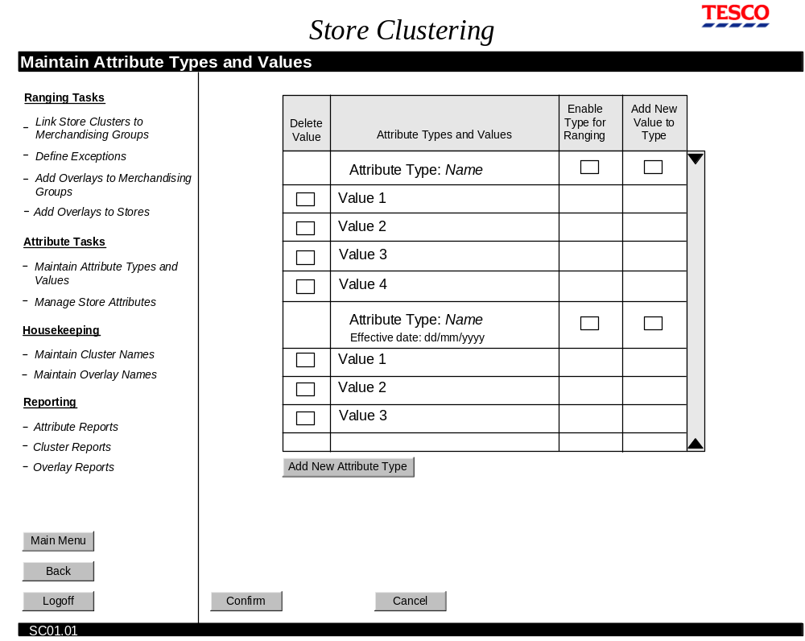
Maintain Attribute Types and Values screen
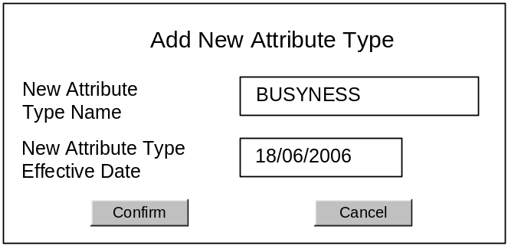
Add New Attribute Type pop-up window

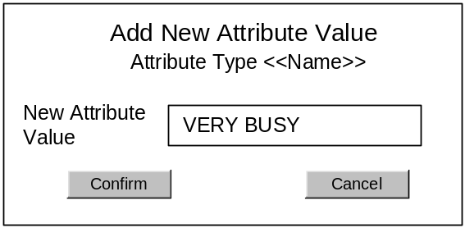
Add New Attribute Value pop-up window
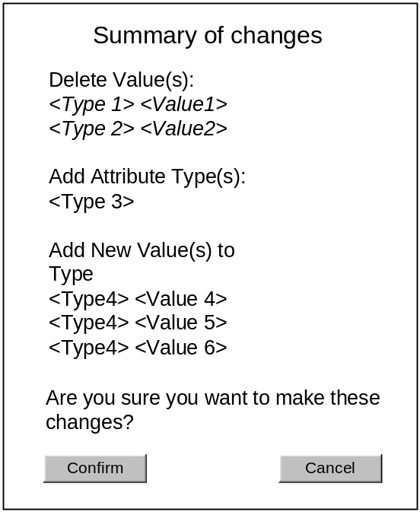
Summary of Changes pop-up window

Field Descriptions
Field | Description | Comment
Delete Value | Check box to select value for deletion | This selection is saved to the database with the Confirm button is pressed
Attribute Types and Values | List of attribute types and their values, obtained from the database. | The Attribute Types enabled for ranging are displayed first, in the order they were created; the attribute types not enabled for ranging are displayed next, also in the order they were created.  Attribute values are displayed in alphabetical order.
Enable Type for Ranging | Check box to select/un-select attribute type to be used for ranging purposes (e.g. store clustering for merchandising groups) | When the screen is first opened, the values held in the database are displayed.  Any changed selections are saved to the database when the Confirm button is pressed.
Add New Value to Type | Check box that opens a pop-up window | When this is checked, the “Add New Attribute Value” pop-up window is displayed.
Add New Attribute Type pop-up window
New Attribute Type Name | An editable description field, maximum 25 alphabetic or numeric characters, spaces allowed, no symbols. | This description field is blank when it is first displayed.
New Attribute Type Effective Date | A date field of the format dd/mm/yyyy (e.g. 18/06/2006).  Default value is tomorrow. | This date field shows tomorrow’s date when it is first displayed.
Add New Attribute Value pop-up window
New Attribute Value | An editable description field, maximum 25 alphabetic or numeric characters, spaces allowed, no symbols. | This description field is blank when it is first displayed.

Description of Screen Functions
When this screen is first accessed, the Attribute Types and Values that are currently defined are displayed. The Attribute Types that have been selected for ranging purposes will be indicated by a tick in the “Enable Type for Ranging” box.

To delete a value, the “Delete Value” box next to the Value should be checked. The deletion is removed from the screen and saved to the database when the Confirm button is pressed.

To enable an attribute type for ranging, the “Enable Type for Ranging” check box next to the attribute name should be checked. The selection is saved to the database when the Confirm button is pressed.

To add a new value to an attribute type, the “Add New Value to Type” check box, next to the attribute type name, should be checked. This action opens the “Add New Attribute Value” pop-up window. The Add New Attribute Value window will show the name of the Attribute Type that this value is to belong to, just below the window title. The user will enter the name of the new value in the New Attribute Value description box. Pressing Confirm on this pop-up window will return the user to the Maintain Attribute Types and Values, where the new attribute value will be displayed in the list.

To add a new attribute type, the “Add New Attribute Type” button should be pressed. This action opens the “Add New Attribute Type” pop-up box. The “Add New Attribute Type” pop-up box allows the user to define the name of the new attribute value, and its effective date. By default, the effective date will display tomorrow’s date. Pressing Confirm on this pop-up window will return the user to the Maintain Attribute Types and Values, where the new attribute type will be displayed in the list, with its effective date displayed beneath it. The user will now have to check the “Add New Value to Type” check box to add at least 2 values to the new type. A value with the name “No Value” is permissible as the second attribute value for a new type.

Pressing the Confirm button displays the “Summary of Changes” window. The Summary of Changes window summarises all the changes that have been made and requested during this session. Pressing the Confirm button on the Summary of Changes pop-up window writes the changes to the database.

Pressing the Cancel button cancels all the changes made during this session and returns the screen selections to how they were when the user first opened the screen.

Focus remains on the Maintain Attributes Types and Values screen when either the Confirm or Cancel buttons are pressed, except if New Attribute Type has been added, in which case pressing Confirm takes the user to the Manage Store Attributes screen.

Validation and Error Handling
Condition | Validation occurs when … | Error message
An attribute type has <2 values associated with it. | User has added a new attribute type and failed to create 2 values for it, and presses the confirm button on the Maintain Attribute Types and Values screen. | An attribute type must have at least 2 values
An attribute type has <2 values associated with it. | User is requesting the deletion of a value that will leave the attribute type with only one value assigned. | An attribute type must have at least 2 values
Effective date has been set as today or a date in the past | User presses the Confirm button on the Add New Attribute Type pop-up window | Effective date must be in the future
User has pressed Confirm on the main screen, requesting the changes they have made to be saved to the database. | User presses the confirm button on the Maintain Attribute Types and Values screen | Summary of Changes screen is displayed
User is trying to add an attribute type that already exists | User has pressed confirm button on the Add New Attribute Type pop-up window | This attribute type already exists
User is trying to add a new value that has the same name as a type | User has pressed confirm button on the Add New Attribute Value pop-up window | This name is already in use as an attribute value. Enter a different name.
User is trying to add an attribute value and has specified a name that already exists | User has pressed confirm button on the Add New Attribute Value pop-up window | This name is already in use as an attribute value. Enter a different name.
User is trying to delete an attribute value that is still assigned to stores | User has pressed confirm button | This attribute value is still assigned to stores and can not be deleted. Please update store attribute values before deleting

Screen SC02: Manage Store Attributes
This screen is used to select attribute values for each store. The screen is designed so that it can be used to as many stores at a time, as required – from a single store to many stores. There are no secondary screens or pop-up windows associated with this screen.

The screen is laid out sequentially and assumes that the previous panel on the screen is completed before the next one is started.

Navigation
The Manage Store Attributes screen is accessed directly from the in-page menu.

Screen Layout
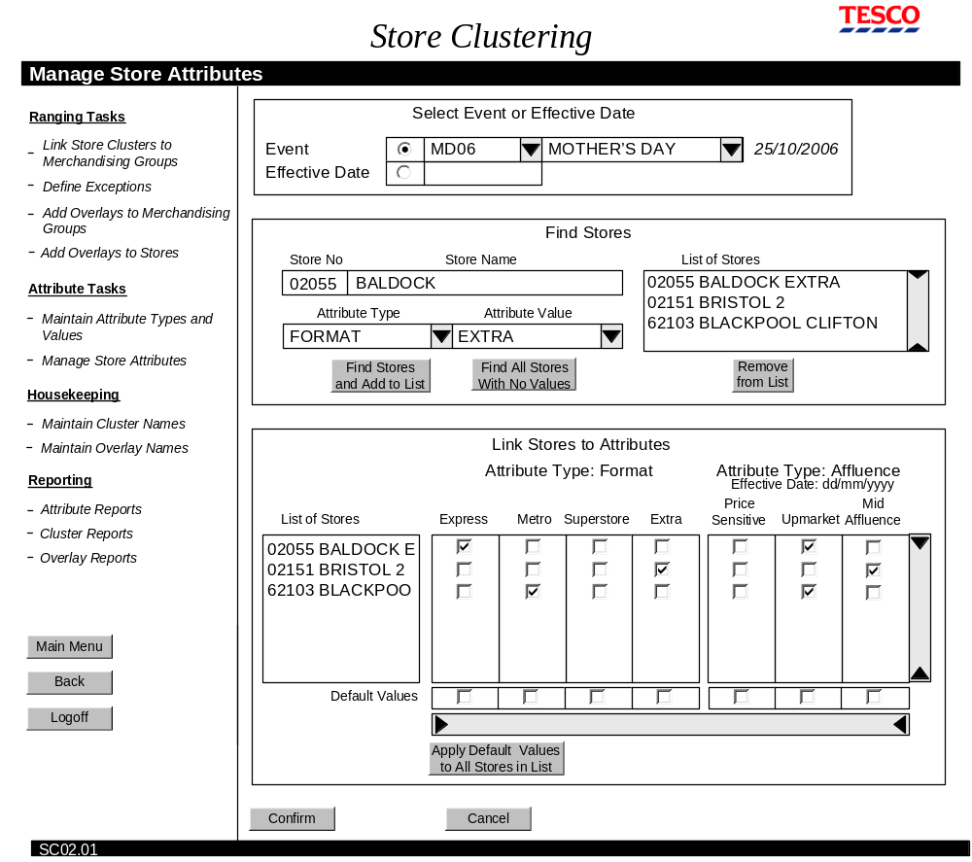
Manage Store Attributes

Field Descriptions
Field |  | Description | Comment
Select Event or Effective Date
Event radio button | Radio button to enable the Event name and id fields |  | This is a toggle button between Event and Effective Date - only one button can be selected at any one time.
Event id | Drop down list of all event ids on the schedule.  Field allows characters to be entered, e.g. typing S will take list focus to those beginning with an S. |  | Selecting an event id will automatically complete the event name field
Event Name | Drop down list of all events on the schedule.  Field allows characters to be entered, e.g. typing S will take list focus to those beginning with an S. |  | Selecting an event name will automatically complete the Event id field
Effective Date radio button | Radio button to enable the Effective Date field |  | This is a toggle button between Effective Date and Event - only one button can be selected at any one time.
Effective Date description | Description date field |  | Date must be entered in the format dd/mm/yyyy
Find Stores
Store Number | 5-number description field |  | Value must be numeric and/or asterisk wildcard.
Store Name | Description field for store name. Field width depends on what the screen design will allow, but must be set to a minimum width of 20 characters, up to a maximum width of 25 characters. |  | Value must be alphabetic, numeric, or asterisk wildcard.
Attribute Type | Drop down list of all the attribute types currently defined, including any that are not yet active.  Field width depends on the screen design, but will be up to a maximum of 25 characters |  | Default value is blank.  Field allows characters to be entered, e.g. typing S will take list focus to those beginning with an S.
Attribute Value | Drop down list displaying all the attribute values for the selected attribute type. In addition, there is a value of “All”.  Field width depends on the screen design, but will be up to a maximum of 25 characters |  | When attribute type is blank, this field is also set to blank.  Field allows characters to be entered, e.g. typing S will take list focus to those beginning with an S.
List of Stores | List of stores numbers and names, built by the user selecting values in the selector fields then pressing the Find Stores and Add to List button, or pressing the Find All Stores with No Values button. |  | Displayed in number order.
Find Stores and Add to List | Button that activates the store selection criteria and returns store numbers and names to the List of Stores |  | Daily feed from CBI loads the data into Store Clustering
Find all Stores with No Values | Button that returns the numbers and names of all stores that have no values assigned to them, to the List of Stores |  | Daily feed from CBI loads the data into Store Clustering
Remove from List | Button that removes the selected stores from the List of Stores.
Link Stores to Attributes
List of Stores | List of store numbers and names, as defined previously in the Find Stores panel. |  | Displayed in store number order.
Attribute Type Name | Name of the attribute type. If it is a new type, the effective date is displayed below the name, until the effective date is reached.
Attribute Type Values | Displays currently defined attribute values for the stores.  If these are stores with no values assigned to them, no values are selected.  User can change selections by checking different boxes. |  | Only one value per attribute type can be selected.
Default Values | Check box selectors |  | Only one value per attribute type can be selected.  A value for one attribute type, or more than one attribute type can be checked.
Apply Default Values to All Stores in List | Button to apply the checked selection in the Default Values boxes to all the stores in the list. |  | List of stores refreshes to show the selected default value. If there are no values selected for an attribute type, the individual selections for the stores are kept.

Description of Screen Functions

Select Event or Effective Date
Linking stores to attribute values can be performed either for a specific event, or more generally using an effective date. Therefore the first step for the user is to select either the event or enter the effective date. This choice is mutually exclusive.

The event can be found using the event name or id; both name and id have drop down lists containing all the events defined on the schedule. Selecting the event name will populate the event id field; selecting the event id will populate the event name field. Once the event name and id fields are populated, the effective date for the event is displayed.

Selecting the Event radio button enables selection from either the Event name or Event id drop-downs, and clears any date that is in the Effective Date description field. Selecting the Effective Date radio button enables the effective date description field, and shows the Event name and Event id fields to be blank.

By default, the Event radio button is selected and all fields blank.

Find Stores
The Find Stores panel enables the user to build a list of stores for the selected event or effective date. The user can search for stores using the store number, name, or an attribute value. The asterisk wild card can be used in the store number and name boxes. In addition to the attribute value, the attribute values drop-down box has the option to select all values.

Only those attribute types enabled for ranging are available in the list of attribute types/values. Selecting an attribute type will populate the attribute values field with the values for that type. Otherwise both attribute type and attribute value files are blank.

The following table gives examples of how to search for stores.

Store Number | Store Name | Attribute Type | Attribute Value | Search Result
02* |  |  |  | All stores whose store number starts with a 1
02* | B* |  |  | All stores whose numbers starts with a 1 and name begins with the letter B.
 | B* |  |  | All stores whose name begins with the letter B
 |  | FORMAT | ALL | All Stores with any value of the FORMAT attribute type

When the search criteria have been entered, the user presses the “Find Stores and Add to List” button. This populates the list of stores with the results of the search. The user can then enter different search criteria, click the “Find Stores and Add to List” button again, and gradually build up a list of stores. The List of Stores is always displayed in store number order, with the store name displayed after the number. If new stores are added, the list is refreshed to display in store number order.

Clicking the Find all Stores with No Values button will add all stores to the list of stores that have no values associated with them. This may be because they are a new store or are a store that has been closed for a major re-fit. Details of these stores are pulled in from CBI automatically. A daily warning message is displayed the first time anyone logs into Store Clustering, listing the names of such stores. The message has a Print button.

Stores in the list of stores can be removed by selecting the store names then clicking the Remove from List button. Selecting list items is performed in the usual way: single stores are selected by clicking them with the mouse or tabbing to them; multiple stores adjacent to each other in the list are selected by holding down the shift key; multiple stores not adjacent to each other are selected by holding down the Ctrl key.

Link Stores to Attributes
Moving focus out of the Find Stores panel will populate the Link Stores to Attributes panel. The List of Stores is that which was defined in the Find Stores panel. The currently defined attribute types and values for those stores are displayed in the grid.

If any of the attribute types are new and not yet active, the effective date for them is displayed below the attribute name.

The user can select different values for a store by simply checking the corresponding check box in the grid. Checking a new value will automatically un-select the previously selected value and ensure that only one value per attribute type can be selected.

Default Values offers the user an opportunity to apply the same set of values to all the stores in the list. To do this the user selects values for one of more attribute types in the Default Values grid. Then, by selecting the “Apply Default Values to All Stores in List” the default values overwrite the current selection of that attribute type. A warning message is displayed for the user to confirm the use of default values.

If the user decides to remove a store from the list of stores when they are working in the Link Stores to Attributes panel, they can return to the Find Stores panel and amend
the List of Stores there. Upon returning to the Link Stores to Attributes grid, the list of stores in this grid will be amended to show the changes – newly selected stores will be added to the list and deleted stores will be removed.

Confirm/Cancel
When the Confirm button is pressed, if any store does not have a value for an attribute type, the store name is displayed in red and an error message is displayed.

Any new stores brought into the system at this point must be assigned values for every attribute type. This is true even if the effective date for the store has not yet been reached. This means that all stores in the Store Clustering system are assigned values for all attribute types – there are no stores that are only part-assigned.

Focus remains on the Link Stores to Attributes screen when either the Confirm or Cancel buttons are pressed.

Validation and Error Handling
Condition | Validation occurs when … | Error message
Effective date must be entered in the format dd/mm/yyyy | Focus is taken out of the Effective Date description field | Date must be entered in the format dd/mm/yyyy
Effective date has been set as today or a date in the past | Focus is taken out of the Effective Date description field | Effective date must be in the future
Warning message for the use of default values | User has pressed the “Apply Default Values to All Stores in List” | Are you sure you want to replace the current selection with default values?
User has pressed the “Apply Default Values to All Stores in List” button but no default values are selected. | The “Apply Default Values to All Stores in List” button is pressed. | There are no default values selected.
One store or more has no value set for an attribute type | The Confirm button is pressed. | A store must have one value for every attribute type. Select values for those stores shown in red.
To return stores with no values assigned to them, at least one such store must exist. | The Find all Stores with No Values button is pressed | There are no new stores

Screen SC03: Link Store Clusters to Merchandising Groups
The purpose of this screen is to group stores according to their attribute values, for raging specified merchandising groups for a named event.

The screen is laid out sequentially and assumes that the previous panel on the screen is completed before the next one is started.

Navigation
The Link Stores to Attributes screen is accessed directly from the in-page menu.

Screen Layout
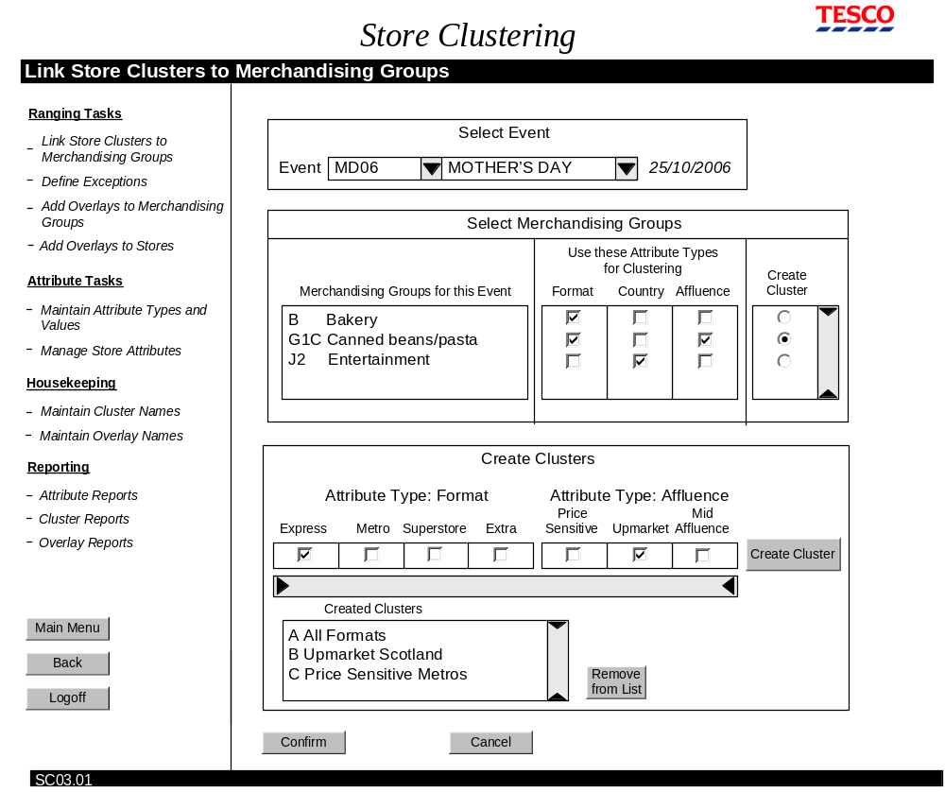
Link Store Clusters to Merchandising Groups screen
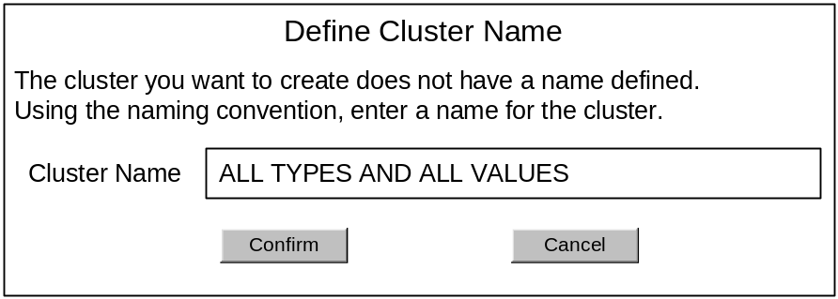

Field Descriptions
Field | Description | Comment
Select Event
Description as in section 2.1.2.3, screen SC02 Manage Store Attributes, without Effective Date
Select Merchandising Groups
Merchandising Groups for this Event | Non-selectable list of merchandising groups associated with this event
Use these attributes for Clustering | List of all the attribute types defined in the system as being enabled for ranging purposes.  Check boxes below each one for selection. | The selected attribute types are made available in the Create Cluster panel once the merchandising group that are to have clusters created are selected
Create Clusters? | Check box to select which merchandising groups are to have clusters created for them.
Create Clusters
Attribute Types and Values | The attribute types selected for clustering, plus their values. | The attribute types to be used for clustering are selected in the “Use these Attribute Types for Clustering” check boxes
Create Cluster | Button that adds the defined cluster to the list of Created Clusters | All cluster names will have been defined at system set-up. If the created cluster defined does not have a name defined, the “Define Cluster Name” pop-up window s displayed.
Remove from List | Button that removes the selected clusters from the list of Created Clusters.
Define Cluster Name
Cluster Name | Description field for new cluster name. Field width ??? tbd - see housekeeping screen – define cluster names

Description of Screen Functions

Select Event

Description as in section 2.1.2.4, screen SC02 Manage Store Attributes

Select Merchandising Groups
Upon leaving the Select Event Panel, the list of merchandising groups for this event is populated and any values that are valid on the effective date for “Use these Attribute Types for Clustering”. For a new merchandising group there will be no attribute types for clustering selected.

If necessary, the user can change the attribute types used for clustering. Attribute types for clustering are displayed at the top of the Create Cluster panel.

The user then selects one of the merchandising groups to have clusters defined.

Create Clusters
When focus moves to the Create Clusters panel:
- The Attribute types and values selected for clustering are displayed (as selected in the Use these Attribute Types for Clustering grid). There are no values checked.
- The Created Clusters list displays any previously defined clusters for the selected merchandising group.

To create a cluster the user selects the attribute values that are to be grouped together, then presses the Create Cluster button. The cluster name is added to the list of Created Clusters. The selected values remain checked in the attribute type/values selection boxes.

There is no restriction on the number of values selected for each cluster. If required, all values of a type can be selected. Selecting no values for an attribute type is the same as selecting all values.

If a cluster is created that does not have a name defined, the “Define Cluster Name” pop-up window is displayed. This allows the user to enter a name for the cluster. The name is added to the list of cluster names that can be accessed through the “Maintain Cluster Names” screen.

Selecting a cluster in the list of Created Clusters will populate the attribute type/values selection boxes with the selection values used to create this cluster.

Clusters in the list of Created Clusters can be removed by selecting the cluster name then clicking the Remove from List button. Cluster selection is performed in the usual way: single clusters are selected by clicking them with the mouse or tabbing to them; multiple clusters adjacent to each other in the list are selected by holding down the shift key; multiple clusters not adjacent to each other are selected by holding down the Ctrl key.

If a cluster is removed from the list of Created Clusters, the selection of checked values in the Create Cluster grid is also removed, leaving no values checked.

The Created Clusters list is displayed in the order in which the clusters are created.

Region Code
Single digit Region Codes are automatically generated and added to the Created Clusters when the Confirm button is pressed. Region codes are added sequentially, using the permitted letters in the range A-Z first, followed by the number 0-9. If a cluster is deleted from the list, the region code that was associated with it is used for the next cluster to be created.

Region codes are unique within an event, for each merchandising group/cluster.

Confirm/Cancel
When the user has created all the clusters they want for this event/selection of merchandising groups, they press the Confirm button. This saves the cluster definitions to the database. Focus remains on the Create Store Clusters screen with all the previous selections still visible.

Pressing the Confirm button checks that every possible combination of values is contained in a cluster. If it is not, the changes are not saved and a message is displayed advising the user that the changes cannot be saved and which values are not included in clusters. The message window has a print button. The clusters that have been defined remain on the screen until the Confirm button is pressed successfully, or until the Cancel button is pressed or one of the Main Menu, Back or Logoff selections are made.

Pressing the Cancel button retains the focus on the screen but removes any field selections.

Validation and Error Handling
Condition | Validation occurs when … | Error message
A merchandising group must be selected before a cluster can be created | Create Cluster button has been pressed | Select a merchandising group.
An event must be selected before merchandising groups are displayed | Focus moves to the Select Merchandising Groups panel | Select an event.
For each merchandising group, every possible combination of values must be contained in a cluster. | When Confirm button is pressed. | One or more attribute values are not in a cluster. Press the report button for more details.
To return stores with no values assigned to them, at least one such store must exist. | The Find all Stores with No Values button is pressed | There are no new stores

Screen SC04: Define Exceptions
This task allows users to override the attribute values assigned to a store/merchandising group for a particular event or effective date. The screen is designed so that users can choose to define exceptions for one or many stores/merchandising groups.

The screen is laid out sequentially and assumes that the previous panel on the screen is completed before the next one is started.

Navigation
The Link Stores to Attributes screen is accessed directly from the in-page menu.

Screen Layout
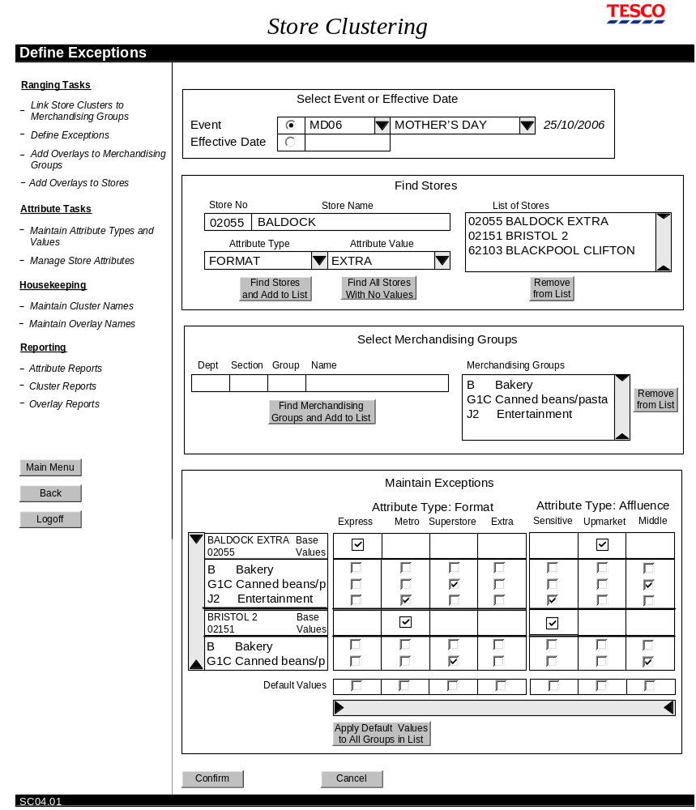
Define Exceptions screen

Field Descriptions
Field | Description | Comment
Select Event or Effective Date
Description as in section 2.1.2.3, screen SC02 Manage Store Attributes
Find Stores
Description as in section 2.1.2.3, screen SC02 Manage Store Attributes
Select Merchandising Groups
Dept | Description field for merchandising group department code. |  | Field will accept only one alphabetic character or an asterisk wildcard.  Field unavailable if Event is selected.
Section | Description field for merchandising section code. |  | Field will accept only one numeric character or an asterisk wildcard.  Field unavailable if Event is selected.
Group | Description field for merchandising group code. |  | Field will accept only one alphabetic character or an asterisk wildcard.  Field unavailable if Event is selected.
Name | Description field for merchandising group name |  | Field will only accept up to 10 alphabetic characters or an asterisk wildcard.  Field unavailable if Event is selected.
List of Merchandising Groups | List of merchandising groups, built by the user selecting values in the selector fields then pressing the Find Merchandising Groups and Add to List button. |  | Displayed in alphabetic order, with the merchandising groups code first
Find Merchandising Groups and Add to List | Button that returns the merchandising group names and codes to the list of Merchandising Groups
Remove from List | Button that removes the selected merchandising group from the list of Merchandising Groups.
Maintain Exceptions
Store name and number | Store name and number retrieved using the Find Stores panel | Stores are listed in number order.
Base values | Static data that shows the attribute values that are saved in the database for the selected store | These values are not selectable or changeable.
List of merchandising groups | Merchandising groups retrieved using the Select Merchandising Groups panel. | Merchandising groups are listed in the same order as in the list of Merchandising groups
Attribute types and values | Check boxes for setting up exceptions for this store/merchandising group | Check boxes initially display any exceptions that are currently defined for this store/merchandising group. Only one value per attribute type/ merchandising group can be selected. Selecting one check box automatically un-selects any other selection for that attribute type/ merchandising group
Default Values | Check box selectors | Only one value per attribute type can be selected.  A value for one attribute type, or more than one attribute type can be checked. If there are no values selected in Default Values for an attribute type, the individual selections for the merchandising groups are kept.

Description of Screen Functions

Select Event or Effective Date

Description as section .1.2.4, screen SC02 Manage Store Attributes

If an event has been selected, when focus leaves the Select Event or Effective Date panel, the list of merchandising groups is populated with the merchandising groups associated with this event.

Find Stores

Description as in section 2.1.2.4, screen SC02 Manage Store Attributes

To optimise the screen layout, the list of stores should display up to a maximum of 6 stores without scrolling.

Select Merchandising Groups
When the stores have been selected that are to have exceptions defined for them, the next step is to select the merchandising groups that are to be ranged according to the exception.

Exceptions can be defined for merchandising departments, sections or groups.

If the exceptions are for an event, the list of merchandising groups will have been populated with all the merchandising groups associated with this event and the Dept, Section, Group and Name search fields are unavailable.

If the exceptions are for an effective date, the list of merchandising groups will be empty and the user must use the search mechanism to build the list.

The Select Merchandising Groups panel enables the user to build the list of merchandising groups to have exceptions applied. The user can search for merchandising groups using the department, section or group codes, or the name. The asterisk wild card can be used in any of the fields.

The following table gives examples of how to search for merchandising groups.

Dept | Section | Group | Name | Search Result
B |  |  |  | The merchandising department with code B
B | * | * |  | All groups within the B department
 | 1 |  |  | All merchandising sections with the section code 1.
B | * | C |  | All merchandising groups with department code B and group code C
* |  |  |  | All merchandising departments
 |  | * |  | All merchandising groups
 |  |  | B* | All merchandising groups whose name begins with the letter B
 |  |  | BA* | All merchandising groups whose name begins with the letters BA

When the search criteria have been entered, the user presses the “Find Merchandising Groups and Add to List” button. This populates the list if merchandising groups with the results of the search. The user can then enter different search criteria, click the “Find Merchandising Groups and Add to List” button again, and gradually build up a list of merchandising groups. The List of Merchandising Groups is always displayed in alphabetical/numeric order of code, with the name after the code. If new groups are added, the list is refreshed to display in code order.

Groups in the list of merchandising groups can be removed by selecting the group code and name, then clicking the Remove from List button. Selecting list items is performed in the usual way: single groups are selected by clicking them with the mouse or tabbing to them; multiple groups adjacent to each other in the list are selected by holding down the shift key; multiple groups not adjacent to each other are selected by holding down the Ctrl key.

If the exception it to be built for an event, the number of possible merchandising groups may be relatively small, therefore it is likely the user would want to display all merchandising groups for this event. If the exception it to be built for an effective date, the number of possible merchandising groups will be extensive, therefore it is likely the user would want to display selected merchandising groups only.

To optimise the screen layout, Select Merchandising Groups and Maintain Exceptions panels will share the available screen space equally.

Maintain Exceptions
Moving focus to the Maintain Exceptions panel populates the grid with details from the List of Stores and the list of Merchandising Groups.

The grid has columns for each attribute type enabled for ranging and it values, and rows for each store/ selected merchandising groups.

In addition, the store’s base values are displayed next to the store name and number. These settings are for reference only and are not editable.

Any exceptions that are already set up for this store/merchandising group combination for the event or effective date are displayed in the grid.

To set up or remove an exception, the user simply checks the selection box below the value. The check boxes for the values that are the same as the base values are not selectable.

Default Values offers the user an opportunity to apply the same set of values to all the Store/Merchandising Groups in the list. To do this the user selects values for one of more attribute types in the Default Values grid. Then, by selecting the “Apply Default Values to All Groups in List” the default values overwrite the current selection of that attribute type. A warning message is displayed for the user to confirm the use of default values.

To optimise the screen layout, Select Merchandising Groups and Maintain Exceptions panels will share the available screen space equally.

Confirm/Cancel/Report
When the user has defined/removed all the required exceptions, they press the Confirm button. A message that summarises the changes is displayed and the user is asked to confirm/cancel the message. Cancelling the message returns the user to the Define Exceptions screen, with all the settings left as they were. Confirming the changes saves the changes to the database and also returns the user to the Define Exceptions screen, with all the settings cleared.

Pressing the Cancel button retains the focus on the screen but removes any previous selections.

Validation and Error Handling
Condition | Validation occurs when … | Error message
Effective date must be entered in the format dd/mm/yyyy | Focus is taken out of the Effective Date description field | Date must be entered in the format dd/mm/yyyy
Effective date has been set as today or a date in the past | Focus is taken out of the Effective Date description field | Effective date must be in the future
At least one store must be selected | Focus is moved to the Select Merchandising Groups panel | At least one store must be selected
To return stores with no values assigned to them, at least one such store must exist. | The Find all Stores with No Values button is pressed | There are no new stores
When an Event has been selected, the search criteria for merchandising groups are unavailable | An Event is selected and the user tries to take focus to any of the Dept, Section, Group or Name fields in the “Select Merchandising Groups” panel. | All the Merchandising Groups for this Event are displayed in the list of Merchandising Groups.
Field is expecting one numeric character or an asterisk wildcard | Entry made in the Section field | The Section code can be only one numeric digit or an asterisk wildcard.
Field is expecting one alphabetic character or an asterisk wildcard | Entry made in the Dept or Group fields | The Department and Group code can be only one alphabetic digit or an asterisk wildcard.
At least one merchandising group must be selected | Focus is moved to the Maintain Exceptions panel | At least one merchandising group must be selected
Warning message for the use of default values | User has pressed the “Apply Default Values to All Groups in List” | Are you sure you want to replace the current selection with default values?
User has pressed the “Apply Default Values to All Groups in List” button but no default values are selected. | The “Apply Default Values to All Groups in List” button is pressed. | There are no default values selected.

Screen SC05 (SC12, SC13): Add Overlays to Merchandising Groups
The purpose of this screen is to associate overlays to merchandising groups.

The next logical step for the user would be to add overlays to stores (screen SC06) so that the ranging changes for the merchandising group selected on this screen would be made available to the store.

The screen is laid out sequentially and assumes that the previous panel on the screen is completed before the next one is started.

Navigation
The Add Overlays to Merchandising Groups screen is accessed directly from the in-page menu. The initial screen shows only the “Select Event or Effective Date” and “What do you want to add?” panels. When the user selects what it is they want to add, the screen is refreshed to display the appropriate screen design.

Screen Layout
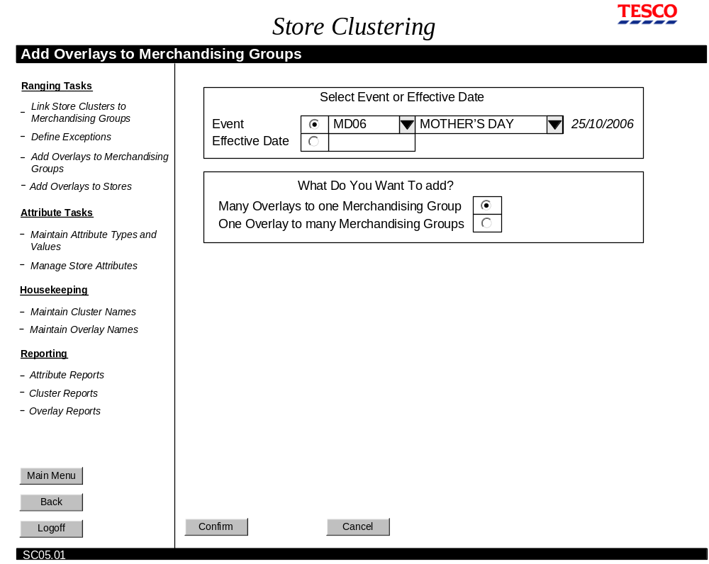

Add Overlays to Merchandising Groups – Initial screen

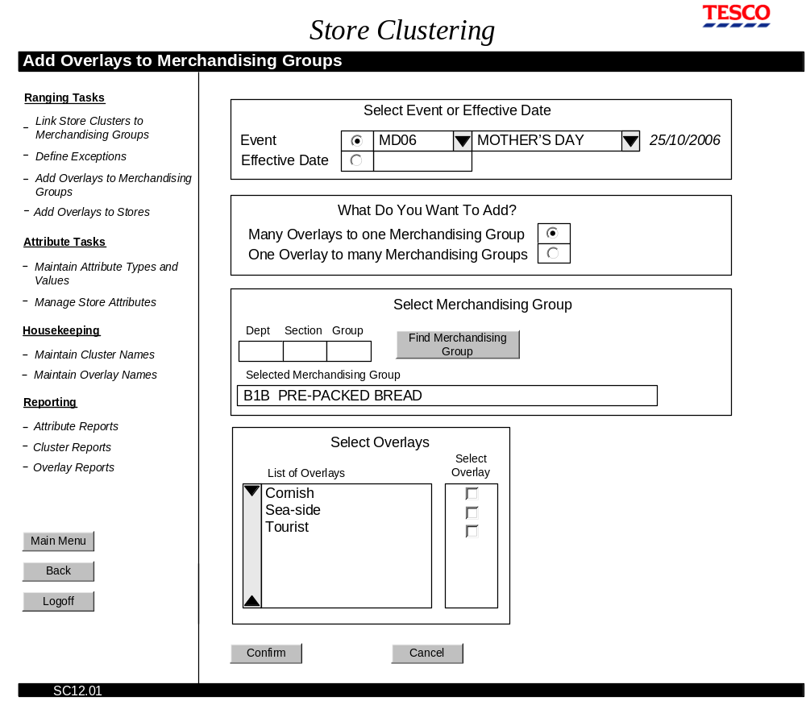
Add (Many) Overlays to (One) Merchandising Groups screen

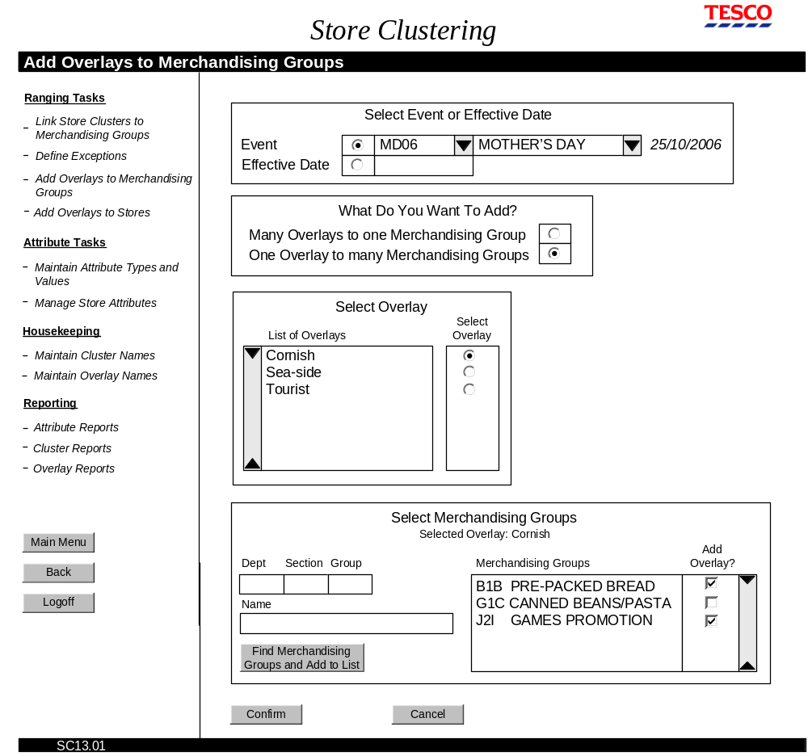
Add (One) Overlays to (Many) Merchandising Groups screen

Field Descriptions
Field | Description | Comment
Select Event or Effective Date
Description as in section 2.1.2.3, screen SC02 Manage Store Attributes
What Do You Want To Add?
Many overlays to one Merchandising Group | Radio button to direct the screen refresh | This is a toggle button. Only one button can be selected at any one time.  No radio button is selected when the screen is first displayed.
One overlay to many Merchandising Groups | Radio button to direct the screen refresh | This is a toggle button. Only one button can be selected at any one time.  No radio button is selected when the screen is first displayed.

Many Overlays to One Merchandising Group
Select Merchandising Group
Dept | Description field for merchandising group department code. | Field will accept only one numeric character.  If Event was selected, the Merchandising Group can be selected only from the merchandising groups available for that Event.
Section | Description field for merchandising section code. | Field will accept only one alphabetic character.
Group | Description field for merchandising group code. | Field will accept only one numeric character.
Find Merchandising Group | Button that returns the merchandising group code and name to the list of Merchandising Groups
Select Overlays
List of Overlays | List of Overlays previously defined | Un-editable list, created using the Maintain Overlay Names screen
Select Overlay | Check box that selects the overlays to be assigned to the selected merchandising group

One Overlay to Many Merchandising Groups
Select Overlay
List of Overlays | List of Overlays previously defined | Un-editable list
Select Overlay | Radio boxes that allow the user to select one overlay | When the screen is first displayed, no overlay is selected. Only one selection is allowed. Selected a second will un-select the first.
Select Merchandising Groups
Description as in section 2.1.4.2, screen SC04 Exceptions, without the Remove from List button.
Add Overlay | Check boxes to select which merchandising groups will be assigned the selected overlay. | Selected overlay is displayed below the Select Merchandising Groups panel title.

Description of Screen Functions

Select Event or Effective Date

Description as in section 2.1.2.4, screen SC02 Manage Store Attributes

What do you want to add?
Selecting one of these radio buttons dictates how the screen is drawn. The radio buttons toggle. Neither button is selected when the screen first appears.

Many Overlays to One Merchandising Group: Select Merchandising Group
Once the event or effective date has been selected, the next step is to select the merchandising group that is to have ranging overlays added to it.

The user types in the merchandising code of the group then presses the Find Merchandising Group button. The Selected Merchandising Group field is populated with the full code and name of the selected merchandising group.

If the overlays are for an event, the selected merchandising group must be from the merchandising groups associated with the event.

Many Overlays to One Merchandising Group: Select Overlays
When the merchandising group has been selected, the final step is to select which overlays this group is to have associated with it.

The List of Overlays displays all the overlays currently defined. Rolling the cursor over an Overlay name in the list will display the description of that overlay in a hover box. Overlay names and descriptions are defined using the Maintain Overlay Name screen.

The Select Overlay check boxes allow the user to select the corresponding overlay. When focus moves to the Select Overlays panel, any previously selected overlays for this event /effective date/merchandising group combination will be checked.

Overlay selections can be made by selecting or un-selecting check boxes next to the overlay name.

One Overlay to Many Merchandising Groups: Select Overlay
When the event or effective date has been selected, the next step is to select which overlay is to be associated to the merchandising groups.

The List of Overlays is populated with all the overlays currently defined. Rolling the cursor over an Overlay name in the list will display the description of that overlay in a hover box. Overlay names and descriptions are defined using the Maintain Overlay Name screen.

Next to each overlay name is a radio box that allows the user to select the overlay to be assigned. When the list if first displayed, no overlay name is selected. Only one selection can be made. Selecting a second overlay name will un-select the first overlay name.

One Overlay to Many Merchandising Groups: Select Merchandising Groups
Description as in section 2.1.4.2, screen SC04 Exceptions, without the Remove from List button, and with the following additions.

If the overlay is for an event, the list of Merchandising Groups will be populated with the merchandising groups associated with this event, and the Dept, Section, Group and Name search fields will be unavailable. The Add Overlay check box will be selected/unselected to indicate whether the group is associated with the overlay.

If the overlay is for an effective date, the list of merchandising groups will display any merchandising group that, on the selected date, will have the overlay associated with it.

The Add Overlay box will be selected for any of the merchandising groups that have the overlay associated with it for the selected event.

The Add Overlay? check box allows the user to select/un-select the overlay for the corresponding merchandising group.

Confirm/Cancel
When the user has selected the overlay(s) to add to the selected merchandising group(s), they press the Confirm button. Pressing Confirm displays a confirmation message summarising the changes to be made. Selecting Confirm on the summary message saves changes to the database and returns the user to the Add Overlays to Merchandising Groups screen with all the settings cleared. Selecting Cancel on the summary message returns the user to the Add Overlays to Merchandising Groups screen with all the settings left as they were.

Pressing the Cancel button retains the focus on the screen but removes any previous selections.

Validation and Error Handling
Condition | Validation occurs when … | Error message
Effective date must be entered in the format dd/mm/yyyy | Focus is taken out of the Effective Date description field | Date must be entered in the format dd/mm/yyyy
Effective date has been set as today or a date in the past | Focus is taken out of the Effective Date description field | Effective date must be in the future
At least one merchandising group must be selected | Focus is moved to the Select Overlays panel | At least one merchandising group must be selected
At least one overlay must be selected | The Confirm button is pressed | At least one overlay must be selected

One overlay to many merchandising groups
Field is expecting one alphabetic character | A character other than alphabetic has been entered in the Dept field | Dept code must be one alphabetic digit
Field is expecting one numeric character or an asterisk wildcard | Entry made in the Section field | Section code must be one numeric digit or an asterisk wildcard.
Field is expecting one alphabetic character or an asterisk wildcard | Entry made in the Group field | Group code must be one alphabetic digit or an asterisk wildcard.
Department code must be entered for sections to be returned | Asterisk entered in Section field, but no alphabetic in Dept code | Enter a Department code
Name must be alphanumeric | A character other than alphanumeric has been entered in the Name field | Merchandising name must consist of only alphanumeric characters
Selected Overlay has no stores associated with it | Confirm button is pressed | Warning! The selected overlay has no stores associated with it.

Many overlays to one merchandising group
Field is expecting one alphabetic character | A character other than alphabetic has been entered in the Dept or Group field | Dept and Group codes must be alphabetic
Field is expecting one numeric character | Entry made in the Section field of character other than numeric | Section code must be numeric
A merchandising code must be entered before a name can be returned. | Nothing has been entered in the merchandising dept, section and group codes | Enter a merchandising code
One or more of the selected Overlays have no stores associated with them | Confirm button is pressed | Warning! The following overlays have no stores associated with them:  <overlay names>

Screen SC06 (SC14, SC15): Add Overlays to Stores
The purpose of this screen is to associate overlays with stores. This allows the stores to receive the ranging modifications for the merchandising groups associated with the overlay.

The screen is laid out sequentially and assumes that the previous panel on the screen is completed before the next one is started.

Navigation
The Add Overlays to Stores screen is accessed directly from the in-page menu. The initial screen shows only the “Select Event or Effective Date” and “What do you want to add?” panels. When the user selects what it is they want to add, the screen is refreshed to display the appropriate screen design.

Screen Layout

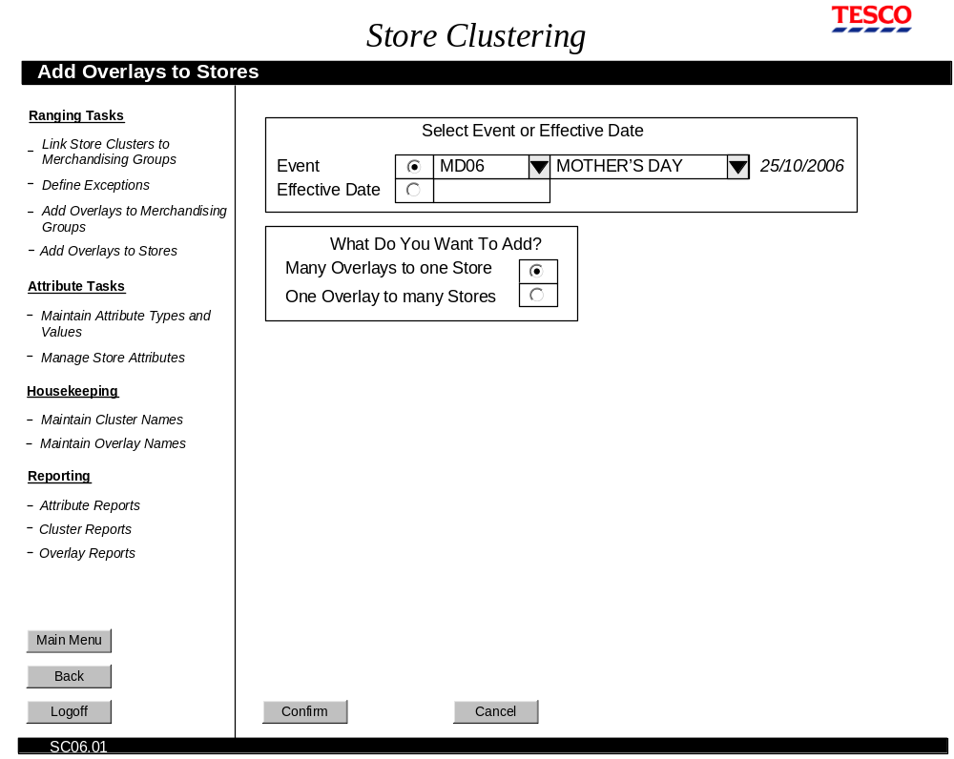
Add Overlays to Stores – Initial Screen

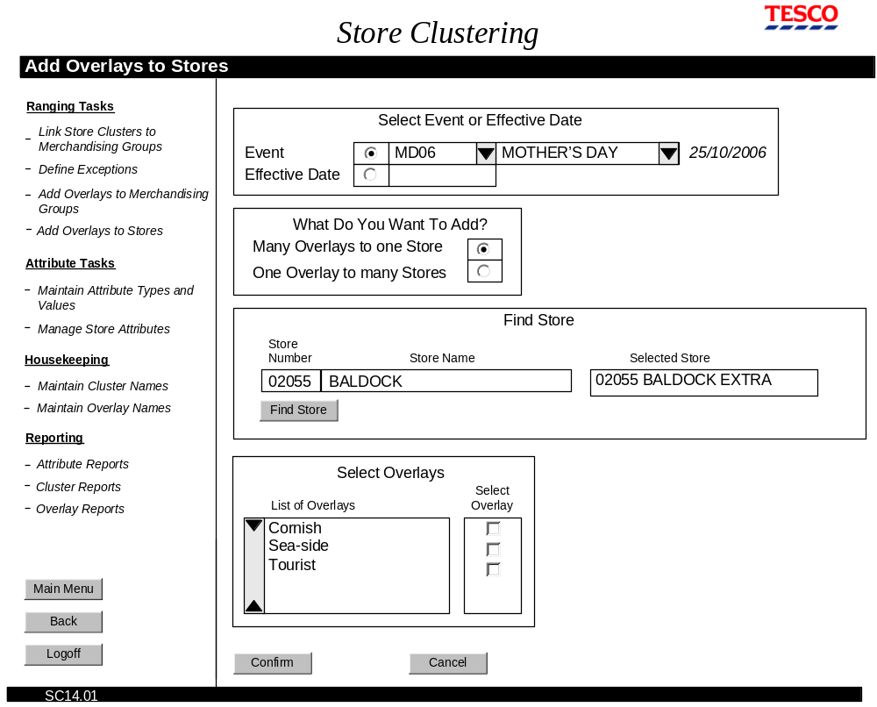
Add (Many) Overlays to (One) Stores screen
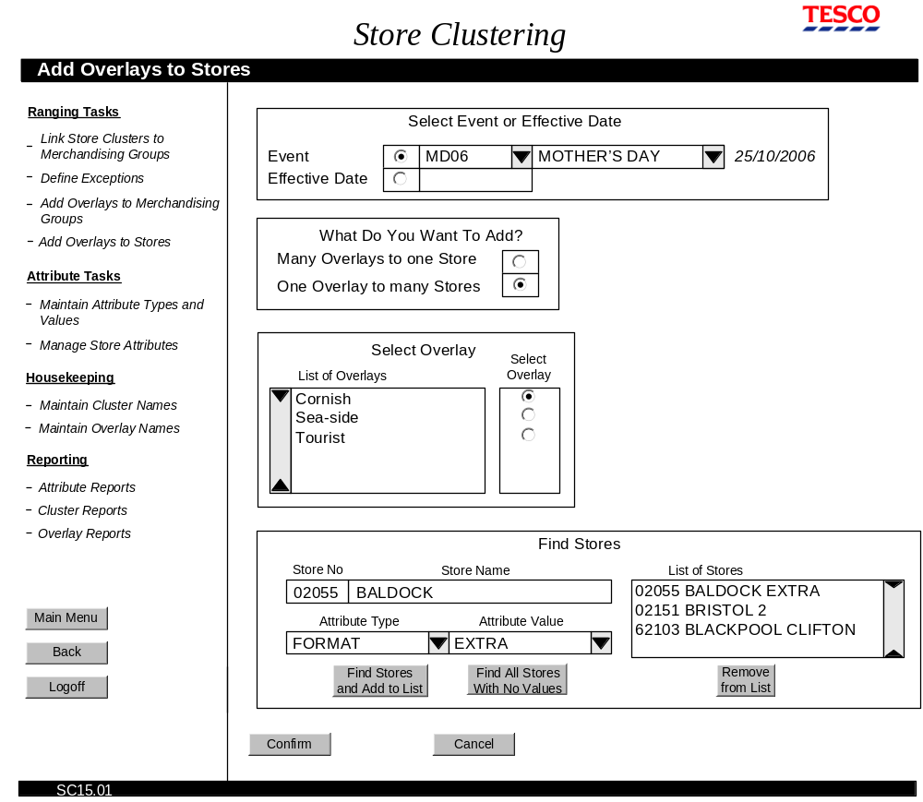
Add (One) Overlays to (Many) Stores screen

Field Descriptions
Field | Description | Comment
Select Event or Effective Date
Description as in section 2.1.2.3, screen SC02 Manage Store Attributes
What Do You Want To Add?
Many overlays to one Store | Radio button to direct the screen refresh | This is a toggle button. Only one can be selected at any one time.  No radio button is selected when the screen is first displayed.
One overlay to many Stores | Radio button to direct the screen refresh | This is a toggle button . Only one button can be selected at any one time.  No radio button is selected when the screen is first displayed.

Many Overlays to One Store
Find Store
Store Number | 5-number description field | Value must be numeric.
Store Name | Description field for store name. Field width depends on what the screen design will allow, but must be set to a minimum width of 20 characters, up to a maximum width of 25 characters. | Value must be alphabetic, numeric.
Selected Store | Complete number and name of store, returned when the user presses Find Store button.
Find Store | Button that returns the complete store number and name based on the user’s partial data.
Select Overlays
Description as in section 2.1.5.3, screen SC05 Add Overlays to Merchandising Groups

One Overlay to Many Stores
Select Overlay
Description as in section 2.1.5.3, screen SC05 Add Overlays to Merchandising Groups
Find Stores
Description as in section 2.1.2.3, screen SC02 Manage Store Attributes, without the Remove from list button.

Description of Screen Functions

Select Event or Effective Date

Description as in section 2.1.2.4, screen SC02 Manage Store Attributes

What do you want to add?
Selecting one of these radio buttons dictates how the screen is drawn. The radio buttons toggle. Neither button is selected when the screen first appears.

Many Overlays to One Store: Find Store
Once the event or effective date has been selected, the next step is to select the store that is to have ranging overlays added to it.

The user types in the store number or name, then presses the Find Store button. The Selected Store field is populated with the full number and name of the selected store.

Many Overlays to One Store: Select Overlays
Description as section 2.1.5.4, screen SC05 Add Overlays to Merchandising Groups.

One Overlay to Many Stores: Select Overlay
Description as section 2.1.5.4, screen SC05 Add Overlays to Merchandising Groups.

One Overlay to Many Stores: Find Stores

Description as in section 2.1.2.4, screen SC02 Manage Store Attributes, without the Remove from list button.

The Add Overlay? check box allows the user to select/un-select the overlay for the corresponding store. When the store names appear in the list, the check box is selected/unselected to indicate whether the stores are/are not already associated with the overlay.

Confirm/Cancel
When the user has selected the overlay(s) to add to the selected store(s), they press the Confirm button. Pressing Confirm displays a confirmation message summarising the changes to be made. Selecting Confirm on the summary message saves changes to the database and returns the user to the Add Overlays to Stores screen with all the settings cleared. Selecting Cancel on the summary message returns the user to the Add Overlays to Merchandising Groups screen with all the settings left as they were.

Pressing the Cancel button retains the focus on the screen but removes any previous selections.

Validation and Error Handling
Condition | Validation occurs when … | Error message
Effective date must be entered in the format dd/mm/yyyy | Focus is taken out of the Effective Date description field | Date must be entered in the format dd/mm/yyyy
Effective date has been set as today or a date in the past | Focus is taken out of the Effective Date description field | Effective date must be in the future
At least one overlay must be selected | The Confirm button is pressed | At least one overlay must be selected
At least one store must be selected | The Confirm button is pressed | At least one overlay must be selected
To return stores with no values assigned to them, at least one such store must exist. | The Find all Stores with No Values button is pressed | There are no new stores

Many overlays to one Store
Field is expecting numeric characters | A character other than numeric has been entered in the Store Number field | Store Number must be numeric
Field is expecting alphabetic or numeric characters | Entry made in the Store Name field that is not alphanumeric | Section Name must be alphanumeric
Alphanumeric characters have been entered that are not recognised as a store name | Find Stores and Add to List button is pressed | Store Name is invalid
From 1 to 5 numeric characters have been entered that are not recognised as a store code | Find Stores and Add to List button is pressed | Store Number is invalid
One or more of the selected Overlays have no merchandising groups associated with them | Confirm button is pressed | Warning! The following overlays have no merchandising groups associated with them:  <overlay names>

One overlay to many stores
Field is expecting numeric characters or an asterisk | A character other than numeric or asterisk has been entered in the Store Number field | Store Number must comprise numeric characters or the asterisk wildcard
Field is expecting alphabetic or numeric characters or an asterisk | Entry made in the Store Name field that is not alphanumeric or an asterisk | Store Name must comprise alphanumeric characters or the asterisk wildcard
A string of alphanumeric characters with no wildcard asterisk has been entered and not recognised as a store name | Find Stores and Add to List button is pressed | Store Name is invalid
A numeric code has been entered with no asterisk that is not a recognised as a store code | Find Stores and Add to List button is pressed | Store Number is invalid
To return stores with no values assigned to them, at least one such store must exist. | The Find all Stores with No Values button is pressed | There are no new stores
Selected Overlay has no merchandising groups associated with it | Confirm button is pressed | Warning! The selected overlay has no merchandising groups associated with it.

Screen SC07: Maintain Cluster Names
The purpose of this screen is to create and delete cluster names that are used in Link Store Clusters to Merchandising Groups screen.

The screen is not laid out sequentially; the screen comprises two panels that can be used in any order.

Navigation
The Maintain Cluster Names screen is accessed directly from the in-page menu.

Screen Layout
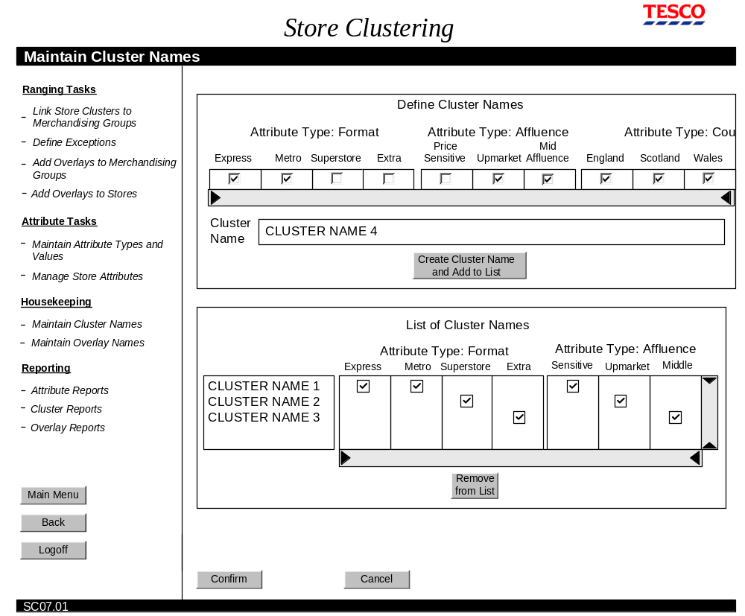
Maintain Cluster Names screen

Field Definitions

Field | Description | Comment
Attribute Types and Values | The attribute types selected for clustering, plus their values. | The Attribute Types enabled for ranging are displayed first, in the order they were created. The Attribute Types not enabled for ranging are displayed second, in the order they were created.
Cluster Name | Description field for cluster name. | Business rules for naming clusters have not yet been defined. This field must therefore allow up to 200 alphanumeric characters.
Create Cluster Name and Add to List | Button that adds the cluster name to the list of cluster names.
List of Cluster Names | List of cluster names plus un-editable ticks that show the attribute values that are contained within the cluster. | The list of names is in alphabetic order.  The attributes are listed in order of creation.  Cluster names cannot be edited, however they can be deleted.
Remove From List | Button that removes the selected clusters from the list of Created Clusters.

Description of Screen Functions

Define Cluster Names
Cluster names can be defined or deleted using this screen; they cannot be edited. The cluster naming convention is managed by the business.

To create a cluster name, the user selects the attribute values that will comprise the cluster. The Attribute Types enabled for ranging are displayed first, in the order they were created. The Attribute Types not enabled for ranging are displayed second, in the order they were created. Then they enter the name of the cluster in the Cluster Name filed, then press the Create Cluster Name and Add to List button. At this point, the new cluster is validated to ensure it is unique in both value combination and name, and the name and values added to the List of Cluster Names.

There is no restriction on the number of values selected for each cluster. If required, all values of a type can be selected. Selecting no values for an attribute type is the same as selecting all values.

List of Cluster Names
Cluster names in the List of Cluster Names can be removed by selecting the cluster name then clicking the Remove from List button. Cluster name selection is performed in the usual way: single names are selected by clicking them with the mouse or tabbing to them; multiple names adjacent to each other in the list are selected by holding down the shift key; multiple names not adjacent to each other are selected by holding down the Ctrl key.

If a cluster is removed from the list of Cluster Names, the name and its attribute values are removed, and the list of names moved up to ensure there is no gap displayed.

The List of Cluster Names is displayed in alphabetic order.

Confirm/Cancel
When the user has defined and deleted all the clusters they want for this event/selection of merchandising groups, they press the Confirm button. This writes the changes to the database. Focus remains on the Define Cluster Names screen so further names can be defined or deleted.

Pressing the Cancel button retains the focus on the screen but removes/restores any new/deleted cluster names.

Validation and Error Handling
Condition | Validation occurs when … | Error message
Cluster names are not case sensitive, and must be unique | Create Cluster and Add to List button is pressed. | This cluster name already exists.
The value combinations that make up a cluster must be unique | Create Cluster and Add to List button is pressed. | This cluster already exists.

Screen SC08: Maintain Overlay Names
The purpose of this screen is to define new cluster names and their descriptions, delete overlay names that are no longer required, edit overlay descriptions.

The screen is not laid out sequentially; the screen comprises two panels that can be used in any order.

Navigation
The Maintain Overlay Names screen is accessed directly from the in-page menu.

The Edit Overlay Description pop-up window is access by selecting the Edit Description check box next to an overlay name.

Screen Layout
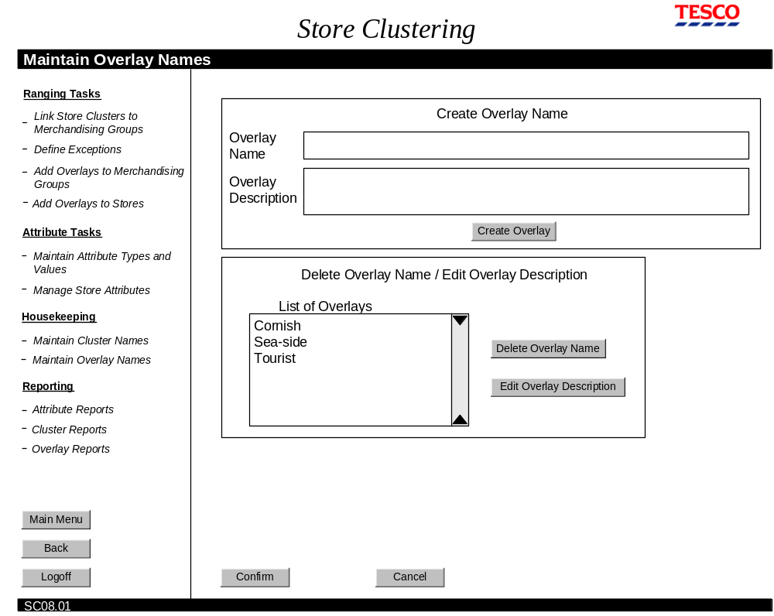
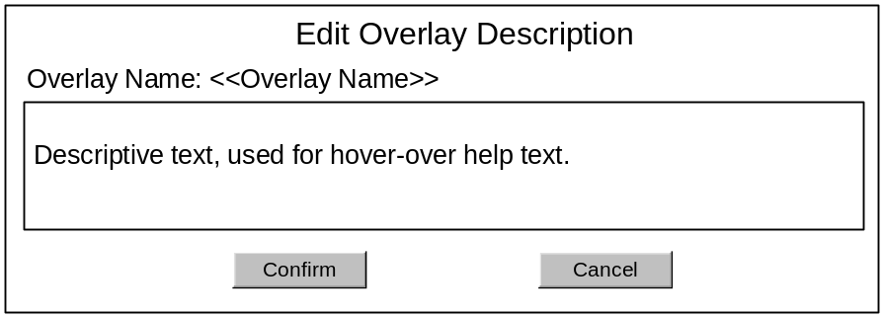
Maintain Overlay Names
Edit Overlay Description pop-up window

Field Definitions
Field | Description | Comment
Overlay Name | Description field ???alphanumeric characters.
Overlay Description | Description field, 256 characters, all character types allowed | The Overlay description appears when the user rolls the cursor over an overlay name on the Maintain Overlay Names screen, Add Overlays to Stores and Add Overlays to Merchandising Groups.
Create Overlay | Button that adds the new overlay name to the List of Overlays | The new overlay is not written to the database until the Confirm button is pressed.
List of Overlays | List of overlay names that are written to the database, or have just been added using Create Overlay Name panel.
Edit Overlay Description | Button that displays the Edit Overlay Description pop-up window for the selected overlay
Delete Overlay Name | Button that removes the selected overlay(s) from the List Of Overlays.
Edit Overlay Description pop-up window
Edit Overlay Description | Description field (as Overlay Description field above) | Populated with the current description.

Description of Screen Functions

Create Overlay Name
To create a new overlay, the user enters the name in the Overlay Name filed, then describes the overlay in the Overlay Description field. Pressing the Create Overlay button adds the overlay name to the List of Overlays. The overlay name is not written to the database until the Confirm button is pressed.

Overlay Descriptions appears when the user rolls the cursor over an overlay name on the Maintain Overlay Names screen, Add Overlays to Stores and Add Overlays to Merchandising Groups.

Delete Overlay Name
To delete an overlay name, the user selects the name from the List of Overlays, then presses the Delete Overlay Name button. An overlay cannot be deleted if it is associated with a merchandising group or as store. A warning message appears if displayed if this is the case.

Edit Overlay Description
To edit an overlay description, the user selects the overlay name in the List of Overlays, then presses the Edit Overlay Description button. This displays the Edit Overlay Definition pop-up window. The window displays the current text and allows the user to edit it. Pressing the Confirm button saves the description; pressing the Cancel button closes the pop-up window without saving the changes.

Validation and Error Handling

Condition | Validation occurs when … | Error message
Overlay names are not case sensitive, and must be unique | Create Overlay button is pressed. | This overlay name already exists.
Overlay cannot be deleted if its associated with a store or merchandising group | Delete Overlay Name button is pressed | This overlay cannot be deleted because the following stores and merchandising groups are associated to it:  <<store name>>  <<merchandising group>>
Overlay name can only be alpha | Create Overlay button is pressed | Overlay Name can contain alpha characters only

Reporting Functionality
The following screens have been identified as necessary to provide the required reporting functionality:
SC09: Attribute Reports
SC10: Cluster Reports
SC11: Overlay Reports

Screen SC09: Attribute Reports
This screen allows the user to build a report for any store that show:
- base attribute values
- merchandising group exceptions

Navigation
The Attributes Reports screen is accessed directly from the in-page menu.

Screen Layout
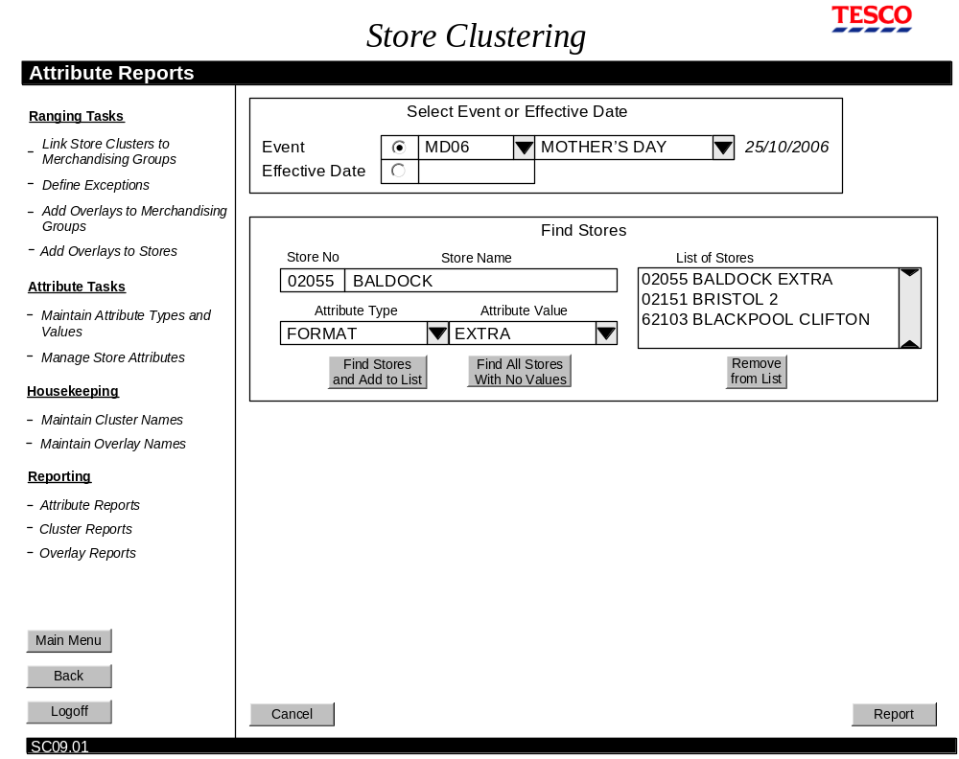
Attribute Reports screen
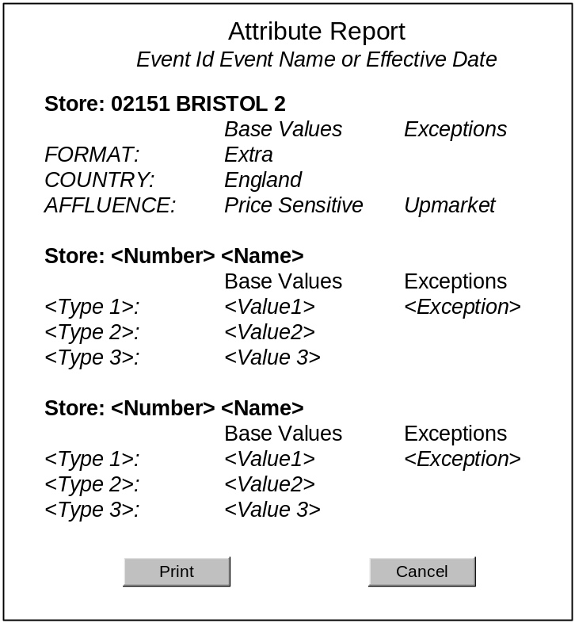
Attribute Report

Field Definitions
Field | Description | Comment
Select Event or Effective Date
Description as in section 2.1.2.3, screen SC02 Manage Store Attributes
Find Stores
Description as in section 2.1.2.3, screen SC02 Manage Store Attributes

Descriptions of Screen Functions

Select Event or Effective Date

Description as section .1.2.4, screen SC02 Manage Store Attributes

Find Stores

Description as in section 2.1.2.4, screen SC02 Manage Store Attributes

Report/Confirm
Pressing the Report button displays the results of the selections made

Validation and Error Handling
Condition | Validation occurs when … | Error message
Standard validation as described for “Select Event or Effective Date” and “Find Stores”

Screen SC10: Cluster Reports
The purpose of this screen is to allow the user to define a report that shows:
- Any merchandising groups for this event or effective date that are not included in a cluster
- Which clusters are assigned to the selected merchandising groups

Navigation
The Cluster Reports screen is accessed directly from the in-page menu.

Screen Layout
The initial screen shows the “Select Event or Effective Date” panel and the “What do you want to Report?” panel. If the user selects to report on “Clusters assigned to Merchandising Groups”, the “Select Merchandising Groups” panel is displayed.

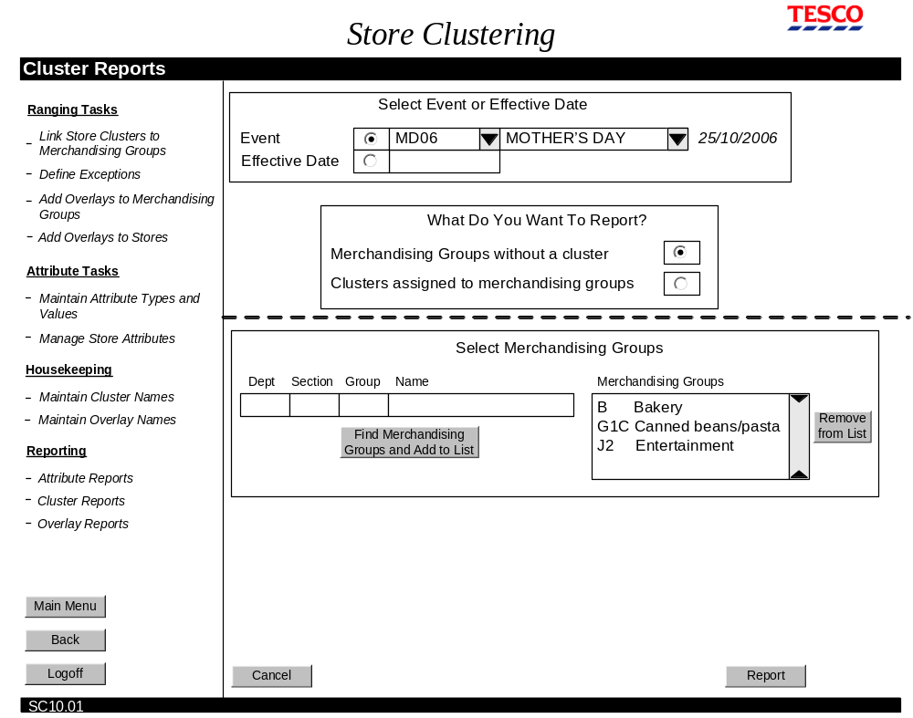
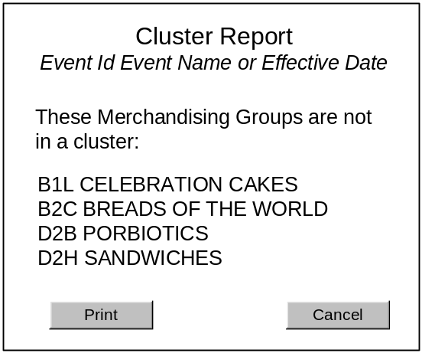
Cluster Reports screen

Cluster Report 1

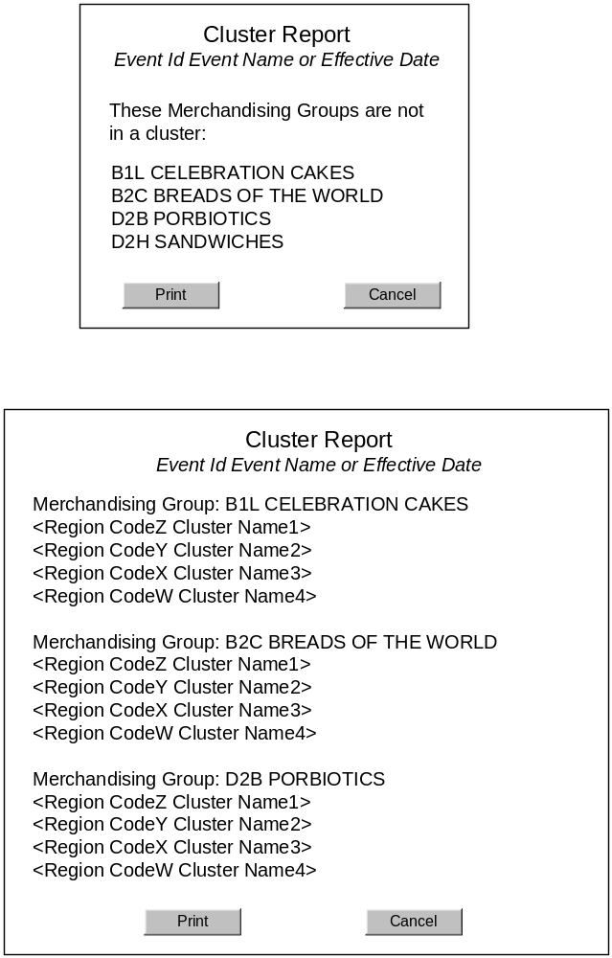
Cluster Report 2

Field Definitions
Field | Description | Comment
Select Event or Effective Date
Description as in section 2.1.2.3, screen SC02 Manage Store Attributes
What do you want to Report?
Merchandising Groups without a cluster | Radio button | By default, this radio button is selected.  Toggle effect with ”Clusters assigned to merchandising groups” – only one radio button can be selected.
Clusters assigned to merchandising groups | Radio button | Toggle effect with ”Merchandising Groups without a cluster” – only one radio button can be selected.
Select Merchandising Groups
Description as in section 2.1.2.3, screen SC02 Manage Store Attributes

Description of Screen Functions

Select Event or Effective Date

Description as section .1.2.4, screen SC02 Manage Store Attributes

What do you want to Report?
The user selects which type of report they want to produce. By default “Merchandising Groups without a Cluster” is selected.

Selecting “Merchandising Groups without a Cluster” radio button navigates the user straight to the report screen.

Selecting “Clusters assigned to merchandising groups” radio button displays the “Select Merchandising Groups” panel.

Select Merchandising Groups

Description as in section 2.1.2.4, screen SC02 Manage Store Attributes

Report/Confirm
Pressing the Report button displays the results of the selections made

Validation and Error Handling
Condition | Validation occurs when … | Error message
Standard validation as described for “Select Event or Effective Date” and “Select Merchandising Groups”
User has selected “Clusters assigned to merchandising groups” report, but has not selected any merchandising groups. | Report button is pressed | Select the merchandising groups to report on.

Screen SC11: Overlay Reports
The purpose of this screen is to allow the user to build a report that shows:
- Which stores and merchandising groups have the selected overlay
- Which overlays the selected store has
- Which overlays the selected merchandising groups have

Navigation
The Cluster Reports screen is accessed directly from the in-page menu.

Screen Layout
The screen is built according to which report the user selects.
- If the user selects “By Overlay”, the “Select Overlay” panel is displayed.
- If the user selects “By Store”, the “Find Store” panel is displayed.
- If the user selects “By Merchandising Group”, the “Find Merchandising Groups” panel is displayed.

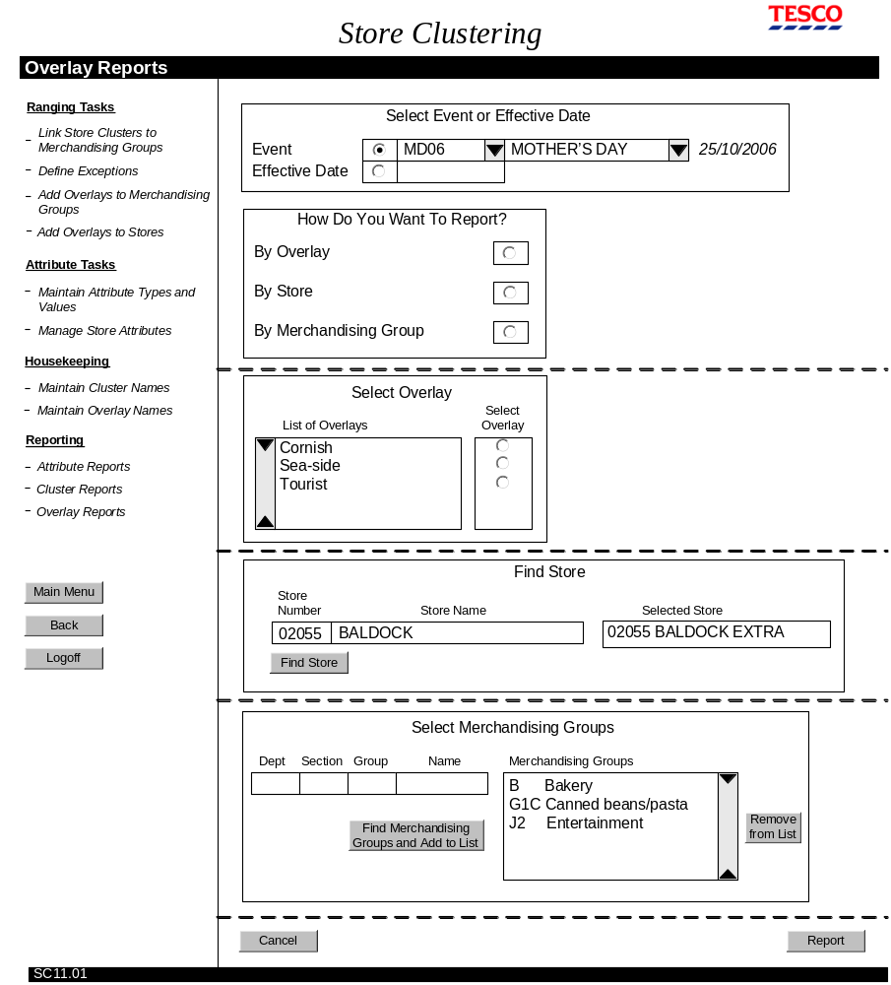
Overlay Reports

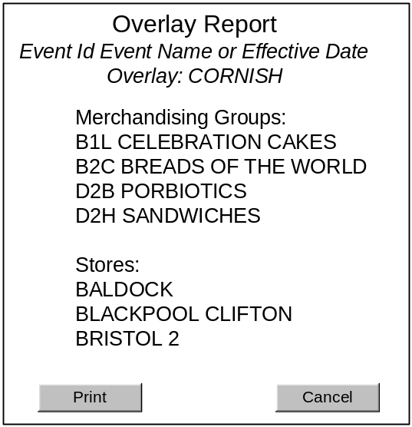

Overlay Report: By Overlay
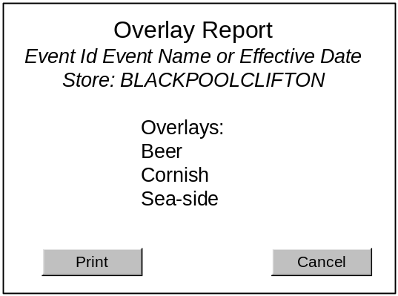

Overlay Report: By Store
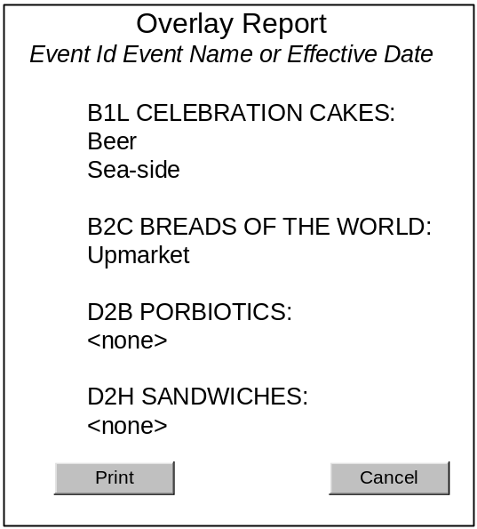

Overlay Report: By Merchandising Groups

Field Definitions
Field | Description | Comment
Select Event or Effective Date
Description as in section 2.1.2.3, screen SC02 Manage Store Attributes
How do you want to Report?
By Overlay | Radio button | By default, no radio button is selected.  Toggle effect with the other 2 buttons – only one radio button can be selected.
By Store | Radio button | By default, no radio button is selected.  Toggle effect with the other 2 buttons – only one radio button can be selected.
By Merchandising Groups | Radio Button | By default, no radio button is selected.  Toggle effect with the other 2 buttons – only one radio button can be selected.
Select Overlay
Description as in section 2.1.6.4, screen SC06 Add Overlays to Stores
Find Store
Description as in section 2.1.6.4, screen SC06 Add Overlays to Stores
Select Merchandising Groups
Description as in section 2.1.2.3, screen SC02 Manage Store Attributes

Description of Screen Functions

Select Event or Effective Date

Description as section .1.2.4, screen SC02 Manage Store Attributes

How do you want to Report?
The user selects which type of report they want to produce. By default, no report is selected.

Selecting “By Overlay” enables the “Overlay” panel and makes the other panels unavailable.

Selecting “By Store” enables the “Find Store” panel and makes the other panels unavailable.

Selecting “Merchandising Groups” enables the “Select Merchandising Groups” panel and makes the other panels unavailable.

Select Overlay

Description as in section 2.1.6.4, screen SC06 Add Overlays to Stores

Find Store

Description as in section 2.1.6.4, screen SC06 Add Overlays to Stores

Select Merchandising Groups

Description as in section 2.1.2.4, screen SC02 Manage Store Attributes

Report/Confirm
Pressing the Report button displays the results of the selections made

Validation and Error Handling
Condition | Validation occurs when … | Error message
Standard validation as described for “Select Event or Effective Date”, “Select Overlay”, “Find Store”, and “Select Merchandising Groups”

Interface with Other Systems
The interface with other systems remains as it is for Pre-Ranging 1.

There is one additional feature that requires adding to the attribute database. That is the flag that signifies whether an attribute type is enabled for ranging.

System and Architectural Changes

Architectural Changes
Store clustering will be developed using .NET 2

System Changes
The following functionality currently in Pre-Ranging 1 will be removed with the introduction of Store Clustering:

- Locking/UnLocking Events. This will be part of the Schedule functionality

Appendices

Appendix A – Terminology
Attribute Type | High-level characteristics used to distinguish different types of stores. The current Attribute Types are:  - Format  - Country  - Affluence
Attribute Value | Values for the Attribute Types that are used to distinguish between different stores.  The current Attribute Values include:  - Format: Extra, Metro, Superstore, Extra,  - Country: England, Scotland, Wales, Ireland  - Affluence: Upmarket, Price Sensitive  Every store must be assigned one value only for each Attribute Type.
Cluster | A group of stores that have selected attribute values in common. When used for ranging, a store cluster will be deemed to display similar trends for retailing a particular merchandise group and will therefore be ranged in the same way.  For example:  - Extras in upmarket areas of Scotland  - Metros in price sensitive areas of Wales
Overlay | Mechanism used to replace part of a range of products with another range of products more suitable for the store. Overlays appear in store-specific Merchandise Plans (SSPOGS), not the Master Merchandise Plan.  Overlays can be used to tailor one range of products (e.g. a Sausage overlay may replace sausages available nationally with sausages made locally) or the products in several merchandise groups (e.g. a Cornish overlay will replace products in merchandise groups such as dairy, ice-cream and cheese).  Overlays can be applied to a single store, or a group of stores.  Other examples:  - A Seasonal overlay used to replace product ranges for many merchandise groups, for stores in popular sea-side locations, e.g. Ilfracombe; Blackpool; Brighton  - A Kosher overlay used to replace product ranges for specific merchandise groups, for stores in areas of high Jewish population such as Finchley.
Attribute Exception | Mechanism used to override a store’s attribute value with a value that can be used for ranging. Exceptions are associated at the Merchandise Group level.  For example:  - A store defined as an Extra may have physical space that is more like a Superstore than an Extra. This would require the store to receive the Superstore product range for some Merchandise Groups.
Region Code | Single character code of the value 0-9 or A-Z, used to define the cluster that the store is in for a particular merchandise group.  Region Code has a 1-to-1 relationship with clusters per merchandise group.  The same region code may be used differently across merchandise groups.  For example, for the same cluster (e.g. Scottish, Upmarket, Extra) merchandise group B1B may have the region code S, and merchandise group B1E the region code T.

